

**Submitted To :** [Propa Punam](https://uits.edu.bd/propa-punam/)

Lecturer, Dept. of CSE

UITS.

**Submitted By :**  Md. Mehadi Hasan, ID : 2125051003

Maheru Tabassum Ohana, ID : 2125051015

Sowrobh Bhuiyan, ID : 2125051026

Mofidul Haque Nibir, ID : 2125051020

**Department :** CSE, **Batch :** 50, **Section :** 7A

**Course Code :** CSE402

**Course Title :** Internet of Things LAB.

**“Project Report”**

**Project Title :** Automated Door.

**Date of Submission :** 11 December, 2024.



**Project Title :** Automated Door.

#### **Abstract :**

This project showcases the development of an automated door system designed to open and close automatically in response to motion detection. The system employs an Arduino Uno R3 microcontroller as its core, paired with a PIR sensor (HC-SR501) to detect movement. A micro servo motor drives the door's operation, ensuring precise and efficient motion. The hardware is assembled using a PVC board for structure, with thermal paste ensuring secure component integration. Additional components, including a USB power-supplying charger cable, jump wires, glue, and stapler pins, were utilized to create a robust and functional prototype. This system demonstrates the application of IoT technologies in automation, providing a hands-free solution for enhanced accessibility and convenience.

#### **Objectives :**

**Automation of Door Operation:** To design a door system that automatically opens and closes based on motion detection, eliminating the need for manual intervention.

**Integration of IoT Components:** To utilize an Arduino Uno R3 microcontroller, PIR sensor, and micro servo motor for seamless and efficient system operation.

**Energy Efficiency:** To optimize the system for minimal power consumption during idle and active states.

**User Convenience:** To enhance user experience by providing a hands-free solution for accessing spaces.

**Prototyping with Practical Materials:** To construct the system using cost-effective and readily available components, including PVC board, USB cables, and jump wires.

**Real-World Application Potential:** To demonstrate the feasibility of smart automation systems in residential and commercial settings.

**Skill Development:** To strengthen technical skills in IoT implementation, including sensor integration, microcontroller programming, and actuator control.

**Equipment and Components :**

1. **Arduino Uno R3 –** The microcontroller unit for controlling the system.
2. **PIR Sensor (HC-SR501) –** For detecting motion to trigger the door's operation.
3. **Micro servo Motor –** To control the opening and closing of the door.
4. **Thermal Paste –** For securing components and ensuring stability.
5. **PVC Board –** Used as the structural base for the system.
6. **USB Power-Supplying Charger Cable –** For powering the Arduino and other components.
7. **Jump Wires –** For establishing electrical connections between components.
8. **Glue –** For assembling and securing parts.
9. **Stapler Pins –** Used for assembling the model.

**Circuit Diagram :   
  
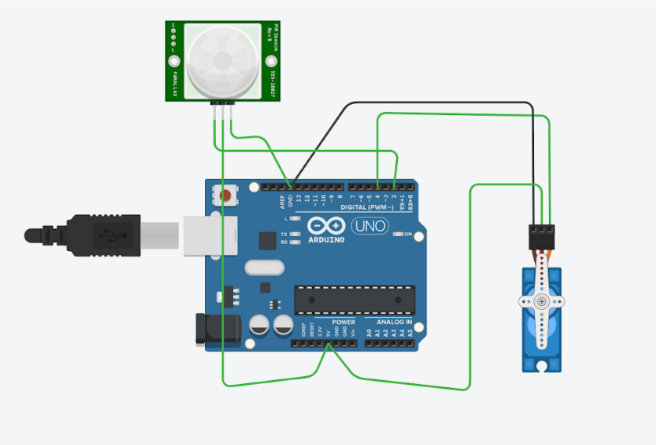**

**Theory :**

The automated door system is a practical application of IoT (Internet of Things) technology, combining motion detection, microcontroller programming, and actuator control to enable seamless automation. The system is based on the integration of various components, each playing a vital role in achieving the desired functionality.

At the core of the system lies the Arduino Uno R3, a microcontroller that processes input signals and controls the output actions. It serves as the brain of the system, interpreting data from the PIR sensor (HC-SR501). The PIR sensor detects infrared radiation emitted by objects in motion, triggering a signal when movement is sensed.

Upon receiving the motion detection signal, the Arduino sends a control signal to the microservo motor, which opens the door by rotating its shaft to a specified angle. The system is programmed to wait for a set time after motion detection and then close the door automatically by reversing the servo motor's movement. This ensures efficient operation without the need for manual intervention.

The physical structure of the automated door is built using a PVC board, chosen for its lightweight and durable properties. The electrical connections are made with jump wires, and additional fastening is achieved using glue and stapler pins to maintain stability. A USB power-supplying charger cable is used to power the Arduino and other connected components. Thermal paste is applied to ensure proper heat dissipation and secure the components in place.

This project illustrates the synergy between sensors, actuators, and microcontrollers in implementing automation. It demonstrates how IoT can be used to create smart, user-friendly solutions for everyday applications, such as improving accessibility and convenience in residential or commercial spaces.

**Methodology :**

The development of the automated door system was carried out through a structured approach comprising the following steps:

#### **1. Component Selection and Procurement -**

* Identified and procured essential components, including Arduino Uno R3, PIR sensor (HC-SR501), microservo motor, PVC board, jump wires, glue, and other supporting materials like thermal paste and stapler pins.

#### **2. Circuit Design -**

* Designed the circuit layout to connect the components effectively.
* Integrated the PIR sensor with the Arduino to detect motion and the microservo motor for door actuation.
* Ensured proper electrical connections using jump wires.

#### **3. Programming the Arduino -**

* Developed the program using Arduino IDE to control the system’s behavior.
* The PIR sensor sends a signal to the Arduino when motion is detected.
* The Arduino processes the signal and commands the servo motor to open the door.
* After a predefined delay, the Arduino commands the servo motor to close the door automatically.
* Uploaded the code to the Arduino Uno R3 via a USB cable.

#### **4. Hardware Assembly -**

* Assembled the physical structure using a PVC board as the base.
* Mounted the PIR sensor and servo motor securely on the structure.
* Applied thermal paste to improve component stability and avoid overheating.
* Used glue and stapler pins for additional structural support.

#### **5. System Testing -**

* Connected the system to a power source using a USB charger cable.
* Tested the PIR sensor for accurate motion detection within the desired range.
* Verified the servo motor’s response to commands for smooth door operation.
* Adjusted delays and motor angles in the program to optimize functionality.

#### **6. Optimization and Debugging -**

* Resolved any issues observed during testing, including incorrect sensor readings or servo motor misalignment.
* Improved system reliability by securing connections and fine-tuning code logic.

#### **7. Final Demonstration -**

* Presented the working prototype of the automated door system.
* Demonstrated how the system opens the door upon motion detection and closes it automatically after a delay.

This methodology ensures a systematic approach to building and refining the automated door system, highlighting its practical application and ease of use.

**Code :**

#include <Servo.h>

const int pirPin = 2;

const int servoPin = 4;

Servo myServo;

void setup() {

pinMode(pirPin, INPUT);

myServo.attach(servoPin);

myServo.write(180);

}

void loop() {

if (digitalRead(pirPin) == HIGH) {

myServo.write(0);

delay(3000);

} else {

myServo.write(180);

}

}

**Observations :**

During the development and testing of the automated door system, the following observations were made:

**1. Loose Connections -**

**Issue:** Initial testing revealed loose connections in the circuit, primarily due to the absence of soldering for permanent attachment.

**Solution:** This issue was mitigated by using thermal paste to secure components in place and ensure stable connections during operation.

**2. Motion Sensor Adjustment -**

**Observation:** The PIR sensor (HC-SR501) required fine-tuning to detect motion within the desired range and avoid false triggers.

**Solution:** Adjusted the sensitivity and detection range of the PIR sensor by carefully calibrating the onboard potentiometer.

**3. Potentiometer Adjustment with Buttons -**

**Observation:** The PIR sensor’s potentiometer acted as two buttons, one for sensitivity and another for time delay. Misadjustment led to delayed or overly sensitive responses.

**Solution:** Precisely calibrated the potentiometers to achieve optimal sensitivity and delay for accurate motion detection and door operation.

These observations were crucial in refining the system's performance, ensuring its reliability, and demonstrating its functionality effectively.

**Result :**

The automated door system was successfully developed and tested, achieving all intended objectives without any errors during operation. The following outcomes were observed:

1. **Error-Free Functionality :**

* The system operated seamlessly, with no glitches or interruptions throughout multiple test runs.

1. **Precise Door Operation :**

* The microservo motor accurately controlled the door movement:
* 0 Degrees: The door opened completely, allowing easy passage.
* 180 Degrees: The door closed securely, ensuring no unwanted openings.

1. **Reliable Motion Detection :**

* The PIR sensor (HC-SR501) effectively detected motion within the calibrated range and triggered the motor to operate accordingly.

1. **Optimal Integration :**

* Adjustments to sensitivity and time delay on the PIR sensor ensured smooth operation without false triggers or delays.
* Thermal paste and secure assembly eliminated loose connections, contributing to the system's stability.

Overall, the project successfully demonstrated a fully functional automated door system, exemplifying the practical application of IoT in home and building automation.

**Discussion and Analysis :**

The automated door system successfully achieved its objectives, demonstrating reliable and error-free operation. Key aspects and observations are discussed below:

1. **System Performance :** 
   * The PIR sensor accurately detected motion and triggered the servo motor for precise door operation, with 0 degrees for opening and 180 degrees for closing.
   * Adjustments to the sensor's sensitivity and delay ensured smooth functionality and minimized false triggers.
2. **Innovative Solutions :** 
   * The lack of soldered connections was effectively resolved using thermal paste, which stabilized the components and ensured consistent performance.
3. **Challenges Faced :** 
   * Fine-tuning the potentiometers on the PIR sensor required careful calibration to achieve the desired sensitivity and delay settings.
   * Maintaining the alignment and smooth movement of the servo motor was critical to ensure seamless door operation.
4. **Practicality and Cost-Effectiveness :** 
   * The system was built using affordable and readily available components, making it a viable solution for smart home automation.
5. **Scope for Improvement :** 
   * Future iterations could include soldered connections for improved durability.
   * Additional features, such as remote control or advanced security options like RFID or biometrics, could enhance the system's functionality and applications.

The project successfully validated the feasibility of using IoT technologies for simple yet effective automation solutions. The integration of sensors, microcontrollers, and actuators highlighted the potential for further advancements in smart home and building automation systems. With minimal adjustments, the system can be scaled or adapted for various applications, such as gates, windows, or even industrial automation.

In conclusion, the automated door system project not only achieved its objectives but also provided valuable insights into the design and implementation of IoT-based systems.

**Conclusion :**

The automated door system was successfully designed and implemented, achieving all objectives without any errors during operation. The system reliably detected motion using the PIR sensor and controlled the door’s movement with the microservo motor, ensuring precise and seamless functionality. Innovative solutions, such as using thermal paste to address loose connections, further enhanced the stability of the prototype.

This project demonstrated the effective application of IoT technologies in creating cost-efficient and user-friendly automation solutions. The error-free performance highlights the reliability of the system and its potential for real-world applications, paving the way for further enhancements and scalability in smart automation systems.

**References :**

1. Circuit Digest, “Automatic Door Opener using Arduino,” [Online]. Available:<https://circuitdigest.com>.
2. Duino4Projects, “Automatic Door Opener Using Arduino,” [Online]. Available:<https://duino4projects.com/automatic-door-opener-using-arduino/>.
3. F. Adan, "Automatic Door System Using Arduino Uno," YouTube, [Online]. Available:<https://www.youtube.com/watch?v=dFz6X1Ol3gI>.